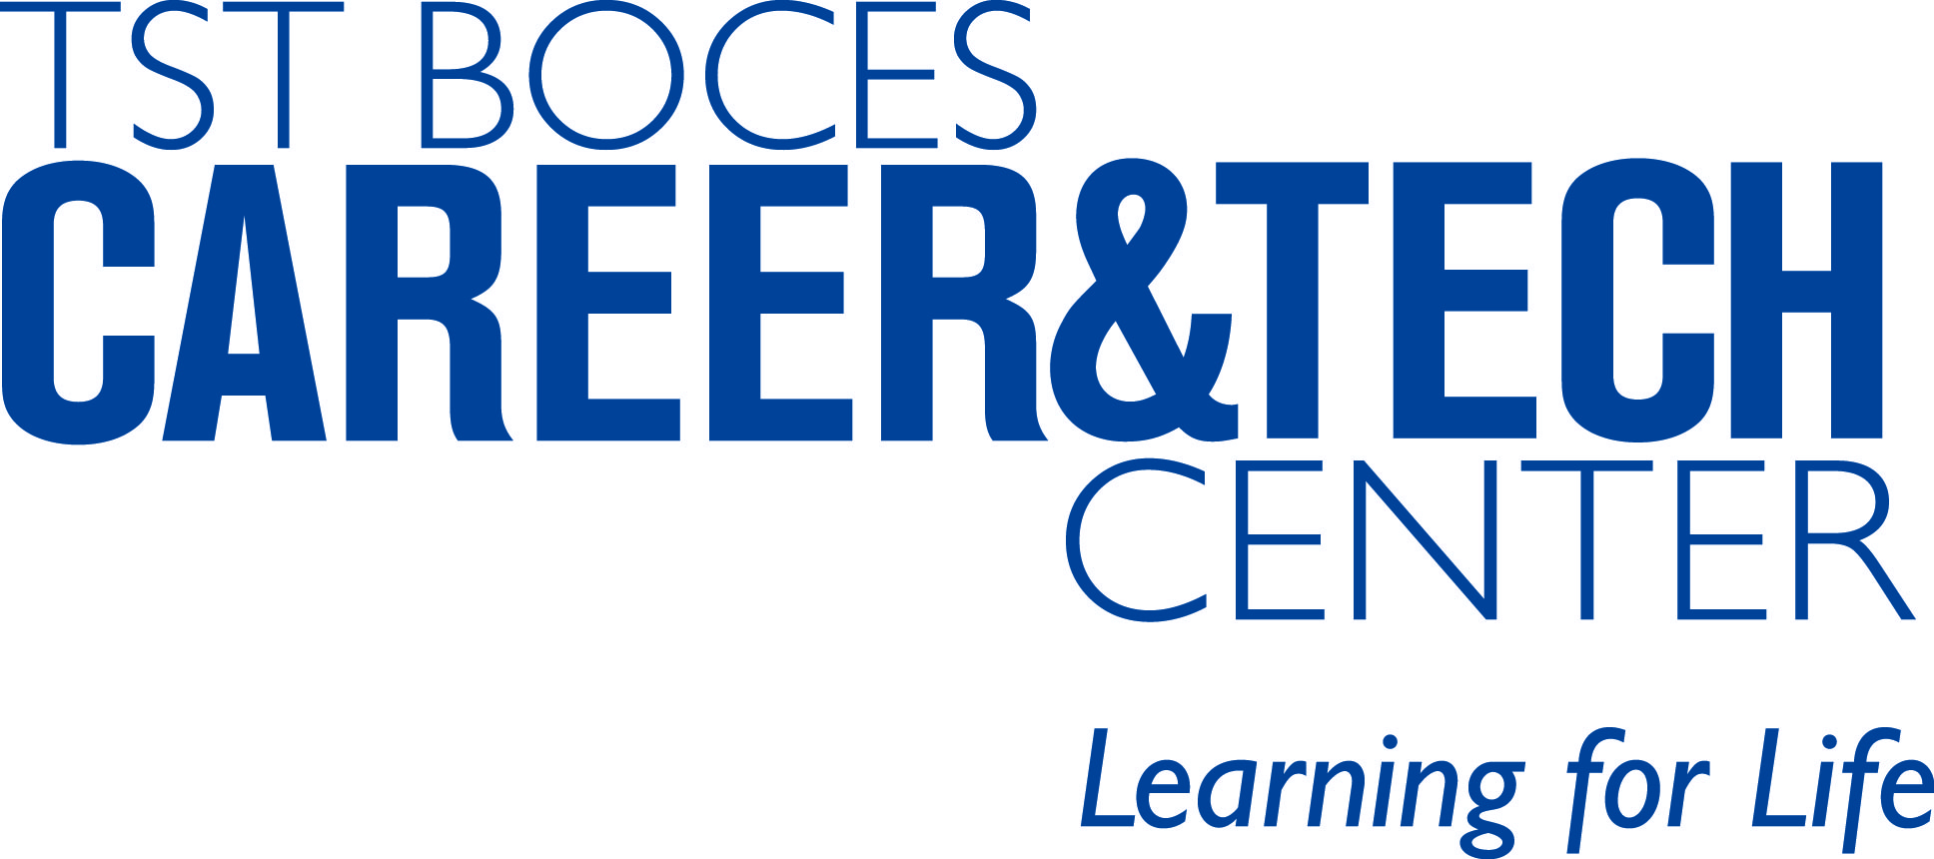

TST BOCES Career and Technical Education Programs

TST | 119999 | Computer and Information Sciences and Support Services, Other | Approved
TST | 120401 | Cosmetology/Cosmetologist, General | Approved
TST | 120503 | Culinary Arts and Related Services, Other | Approved
TST | 190709 | Child Care Provider/Assistant | Approved
TST | 430107 | Criminal Justice/Police Science | Approved
TST | 460201 | Carpentry/Carpenter | Approved
TST | 460302 | Electrician | Approved
TST | 470302 | Heavy Equipment Maintenance Technology/Technician | Approved
TST | 470603 | Autobody/Collision and Repair Technology/Technician | Approved
TST | 470604 | Automobile/Automotive Mechanics Technology/Technician | Approved
TST | 480508 | Welding Technology/Welder | Approved
TST | 511614 | Nurse/Nursing Assistant/Aide and Patient Care Assistant | Approved
TST | 090702 | Digital Media Technology | Not Yet Approved

Tompkins Seneca Tioga BOCES Career and Technical Education Center
555 Warren Road
Ithaca, NY 14850
(607) 257-1551

