BEDS DAY ENROLLMENT VERIFICATION REPORT for
SUPPLEMENTAL COUNTS for STATE AID CALCULATIONS

This report, scheduled for a January 2012 deployment, presents particular student counts that are used in State aid calculations. In general terms, the majority of state aid is reserved for students based on where they are enrolled, however textbook and transportation aid is reserved for students based on their district of residence. For textbook and transportation aid, non-resident enrolled students are excluded while resident students enrolled outside of the district are included. A screen shot of the report is:

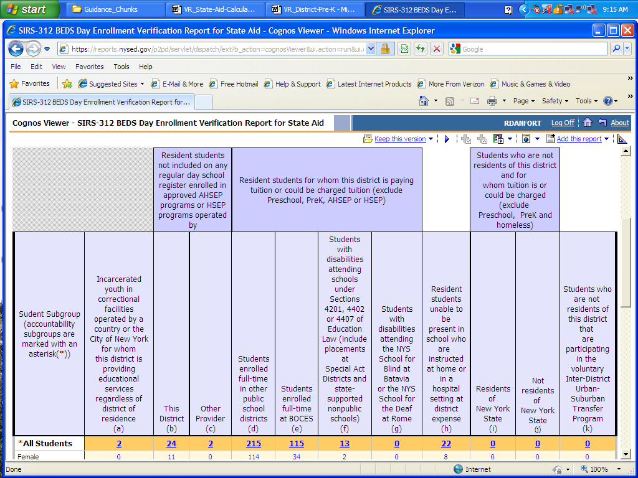

The majority of students in this report fall into two general classes: 1) resident students who are enrolled outside of this district and 2) non-resident students who are enrolled in this district. General examples of such students are:

- resident students placed by the district outside of the district, including special education placements and students enrolled full-time at BOCES.
- resident students attending other public school districts by parental choice.
- resident students unable to attend school and served by the district in home or hospital settings.
- resident students in approved HSEP or AHSEP programs and eligible for Equivalent Attendance Aid.
- non-resident students who are enrolled in the district.
- incarcerated youth in correctional facilities served by the district.

These 2011-12 counts required for State aid can in concept be determined from the Repository, however, the BEDS Online will be the official source for these particular counts required for State aid for 2011-12. These counts required for State aid are currently collected via the BEDS Online on the BEDS District Summary Form in items 1b1, 1b2, 1c, 2, 3 and all of item 4 as follows:

1b. Enter the number of students reported in Item 1a who are not residents of this district and for
whom tuition is or could be charged and who are:
1. residents of New York State (exclude Pre-K and homeless students) …………………
- not residents of New York State (exclude Pre-K and homeless students) ……………
- Enter the number of non-resident students enrolled in this district that are participating in
the voluntary Inter-District Urban-Suburban Transfer Program…………………….
- Enter the number of incarcerated youth served by this district who are in correctional facilities
operated by a county or the City of New York, regardless of district of residence: …………………

- Enter the number of resident students who are over the compulsory age of attendance, who are not included on any regular day school register, and who are in equivalent attendance programs operated by:

a. This district |  | b. a BOCES |  | C. Other

4. Enter the number of resident students for whom this district is paying or could be charged tuition for
education outside of this district. Do not include students counted in Item 3 or Pre-Kindergarten students.
a. Students with disabilities enrolled full time in other public school districts…………………….
b. General education students enrolled full time in other public school districts ………………….
c. Students with disabilities enrolled full-time at BOCES …………………………………………
d. General education students enrolled full-time at BOCES ……………………………………….
e. Students with disabilities attending schools under Sections 4201, 4402 or 4407 of the Education Law. (Include Special Act District placements and placements at state-supported nonpublic schools.)
f. Students with disabilities attending the New York State School for the Blind at Batavia or the New
York State School for the Deaf at Rome ………………………………………………………...

The BEDS Day Enrollment Verification Report for Supplemental Counts for State Aid Calculations and student detail in the repository for 2011-12 should be viewed as a pilot for this level of detail and an opportunity to sort out procedures necessary to arrive at student records in the Repository that can be used as the official source of counts required for State aid use for 2012-13.

A tabular presentation of the types of students included in the BEDS Day Enrollment Verification Report for Supplemental Counts for State Aid Calculations is:

Non-resident students enrolled in this district | are reported in SIRS by:
Students placed in this district by their home district’s Committee on Special Education (CSE). | The student’s home district.
Residents of other school districts placed in this district by their parents. | The district where attending.
Children of staff who are residents of other public schools districts and attending this district tuition free. | The district where attending.
Students who completed the terminal grade in a K-6 or K-8 district and are completing their high school education in this district. | The district where attending.
Students who are residents of other states or countries.  (Note: Foreign exchange students are viewed as temporary residents.) | The district where attending.

Resident students enrolled outside of this district | are reported in SIRS by:
Resident students enrolled full-time in other public school districts, including special education placements. | The home district if placed by the home district; the district where the student is attending if NOT placed by the home district.
Resident students enrolled full-time at a BOCES, including special education placements. | The home district if placed by the home district; BOCES if NOT placed by the home district.
Resident students placed by this district in a Special Act School District. | The home district if placed by the home district.
Resident students with disabilities placed by this district in nonpublic school settings. | The home district if placed by the home district.
Resident students placed by this district in the NYS School for the Blind at Batavia or the NYS School for the Deaf at Rome. | The School for the Blind or the School for the Deaf
Resident students attending Charter schools.* | The Charter school.
Resident students attending Nonpublic schools by parental choice.** | The Nonpublic school if applicable.
* Will only appear in the enrollment verification report for the charter school in which enrolled.
**Will not appear in any district’s BEDS Day Enrollment Verification Report.

The following chart shows which district(s) will see which students in the current scheme in the BEDS Day Enrollment Verification Report for Supplemental Counts for State Aid Calculations. Additional reports and detail will be developed based on need.

Report  Column | Column Description | Who Sees These Students
a | Incarcerated Youth | The district where the correctional facility is located will see all such students; no other district will see these students.
b | Residents in GD – District | The district where the student resides will see its own resident students; no other district will see these students.
c | Residents in GD – Other | The district where the student resides will see its own resident students; no other district will see these students.
d | Residents in Other Districts | The district where the student resides will see its own resident students in Column “d” as enrolled in some other district. The district where the student is enrolled will see the student in Column ”i” as a non-resident student.
e | Residents in BOCES | The district where the student resides will see its own resident students in Column “e” as enrolled in a BOCES. BOCES “may” see them later based on future BOCES reporting requirements for the Repository.
f | Residents in 4201, SpActs | The district where the student resides will see its own resident students in Column “f” as enrolled in a Special Act district, a nonpublic or State-supported school as a special ed placement. Special Act districts will see these students in Column “i” as non-residents.
g | Residents at Rome/Batavia | The district where the student resides will see its own resident students in Column “g” as enrolled in the school for the Deaf or Blind; the school for the Blind or Deaf will see their students in Col “i” as non-residents.
h | Residents Home/Hospital | The district where the student resides will see its own resident students in Column “h” as home- or hospital bound; no one else will see these students.
i | Non-residents – In - NYS | The district where the student is enrollment will see these students in Column “i” as non-residents. The district where the student resides will see their residents in Column “d” as resident students attending other public school districts.
j | Non-residents – Out - NYS | The district where the student is enrolled will see these students in Column “j” as non-residents. No other district will see these students.
k | Inter Distr Urb/Sub Transfer | The district where the student is enrolled will see these students in Column “k” as non-residents. The district where the students reside (Rochester) will see these students in Column “d” as resident students attending other public school districts.

