BEDS DAY ENROLLMENT VERIFICATION REPORT by
LOCATION of ENROLLMENT and STUDENT SUBGROUP

This report presents counts of students by grade for “All Students” and for the subgroups of gender, race/ethnicity, disability status, English proficiency status and economic status. A partial screen shot of this report is as follows:

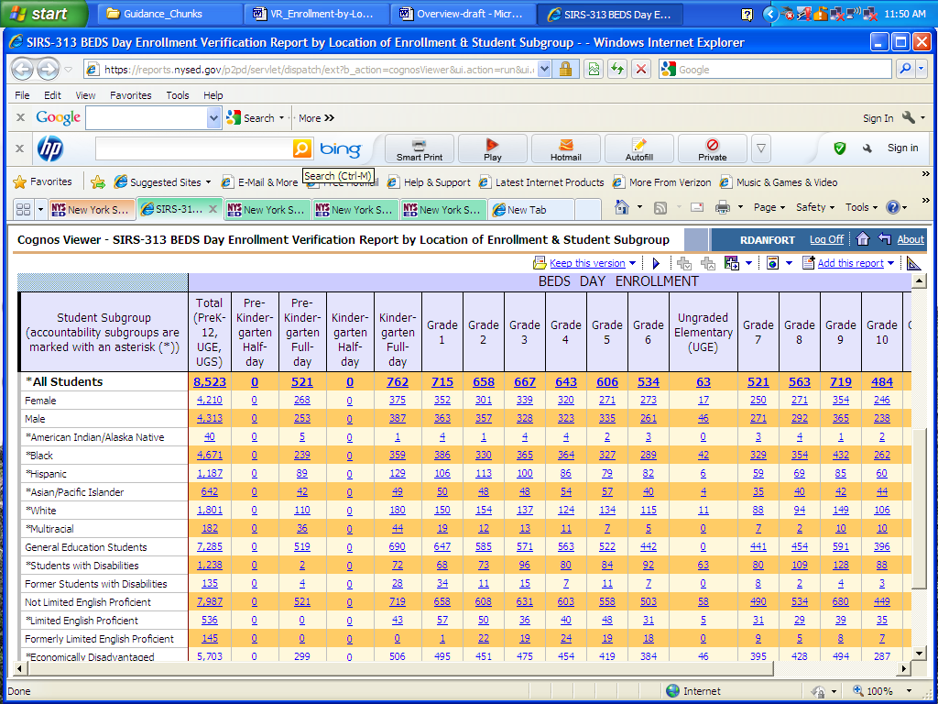

Counts in the “All Students” line of this report (only this one line) will need to be verified and certified by early January for each school year, beginning with 2011-12, and confirmed in early April.

Counts by student subgroup appear in this report to emphasize the importance of these subgroup categories and to provide a mechanism for schools and districts to verify the accuracy and completeness of the data as local awareness of the data evolves prior to assessment verification later in the school year. The subgroup categories appearing in this report are the same as those used in the School Report Card and required for federal reporting. Sub-group and program data for BEDS Day enrolled students will remain open to update through the end of the school year. Final verification for sub-group and program data constituting the accountability subgroups will take place at the end of the school year in conjunction with assessment verification.

The lines of data on this report (BEDS Day Enrollment Verification Report by Location of Enrollment and Student Subgroup) by school that are labeled as “All Students” and the lines immediately below by gender and race/ethnicity replace student counts that were previously collected in item 3 (titled “Enrollment in This School”) on the BEDS the School Data Form via the BEDS Online. Item 3 that is no longer collected on the BEDS School Data Form looked like:

3. Enrollment in This School
Grade | American Indian or  Alaska Native |  | Black or  African American  (not Hispanic origin) |  | Asian or  Pacific Islander |  | Hispanic or Latino |  | White  (not Hispanic origin) |  | Multi-Racial  (not Hispanic origin) |  | Total  Enroll-ment
Grade | Male | Female | Male | Female | Male | Female | Male | Female | Male | Female | Male | Female | Total  Enroll-ment

Prekindergarten
Kindergarten-HD
Kindergarten-FD
First
Second
Third
Fourth
Fifth
Sixth
Ungraded Elem
Seventh
Eighth
Ninth

Tenth
Eleventh
Twelfth
Ungraded Sec
Note: Exclude students attending BOCES full-time. Ungraded Elementary and Ungraded Secondary refer to students with disabilities. Non-graded Non-graded students who are not students with disabilities should be assigned, according to age, to a grade above.

The line of data that is labeled “All Students” on the school level version of the BEDS Day Enrollment Verification Report by Location of Enrollment and Student Subgroup will be recognized as official BEDS day grade-by-grade enrollment for all schools.

The line of data that is labeled “All Students” on the District BEDS Total version of the BEDS Day Enrollment Verification Report by Location of Enrollment and Student Subgroup replace student counts that were previously collected in item “1a” (titled “Enrollment in This District) on the District Summary Form via the BEDS Online. Item “1a” that is no longer collected on the BEDS District summary Form looked like:

1. Enrollment in This District
- Regular day school enrollment by grade in this district. Note: Enrollment in this part “a” will
cumulate automatically as each school’s enrollment data are submitted online.
.

Pre-K* K (half) K(full) 1 2 3 4 5 6 Ungr.Elem.**

7 8 9 10 11 12 Ungr. Sec** Total
* Will automatically populate with the total number of all full- and part-time pre-kindergarten students
reported in Item 1d below.
**Students with disabilities receiving all of their instruction from BOCES personnel (either in BOCES
facilities, district classrooms or other facilities) should be excluded above, and reported in Item 4c.

The line of data that is labeled “All Students” on the District BEDS Total version of the BEDS Day Enrollment Verification Report by Location of Enrollment and Student Subgroup is arrived at by adding the comparable cells for each school in the district plus the Universal Pre-kindergarten (UPK) students who are in Community-based Settings (CBOs) and that have been reported with a Location Code ending in “0666”. The Universal Pre-kindergarten (UPK) students who are in Community-based Settings (CBOs) and that have been reported with a Location Code ending in “0666” are the same Pre-K students who have been reported in item “1d” on the BEDS District Summary Form as the “Number of UPK students in CBO Operated Settings.” (see middle columns below)

 | Universal Pre-K Funded Students  (including former TPK Programs) |  | Number of Pre-K Students NOT Funded by UPK Money
 | Number of UPK Students in District Operated Classrooms | Number of UPK Students in  CBO Operated Settings | Number of Pre-K Students NOT Funded by UPK Money
Half - Day
Full - Day

The line of data that is labeled “All Students” on the District BEDS Total version of the BEDS Day Enrollment Verification Report by Location of Enrollment and Student Subgroup will be recognized as official BEDS day grade-by-grade enrollment for all districts.

BEDS enrollment does not include preschool (PS), GED enrolled students (GD), homebound (Location Code ending in “0777”), home schooled (Location Code ending in “0888”) or out of district placements.

