BEDS DAY ENROLLMENT VERIFICATION REPORT
by DISTRICT of RESIDENCE

This report, scheduled for a January 2012 deployment, presents counts of enrolled students by grade and by their District of Residence. A sample screenshot of this report is:

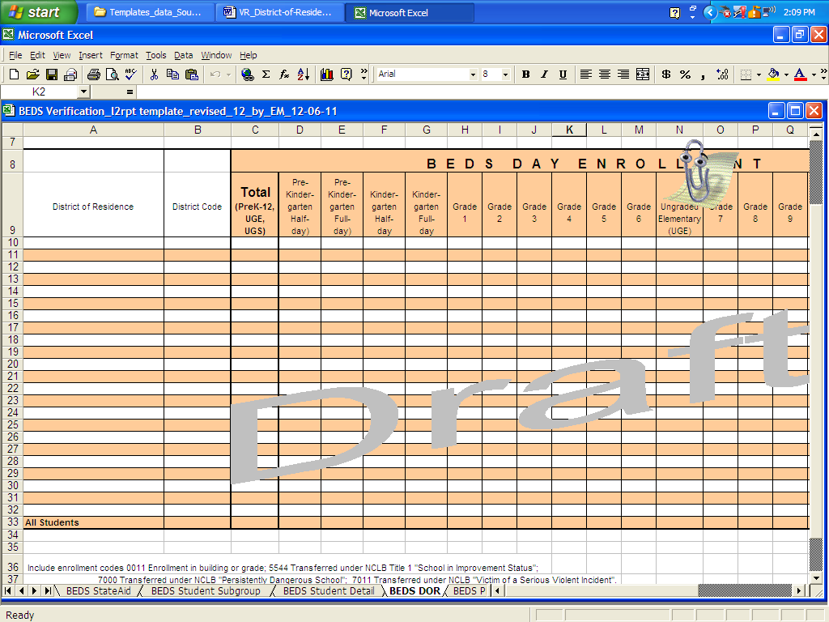

If all enrolled students are residents of the district in which they are enrolled, then each report will show one detail line with all enrolled students appearing as residents of that district, plus the “All Students” line that will be the same as the one detail line. For sake of discussion, if the “All Students” count is “100”, of which “95” students are residents of district A, “4” students are residents of district B and “1” student is a resident of district C, then the report will show three lines, one line showing “95” enrolled students as residents of district A, one line showing “4” enrolled students as residents of district B and one line showing “1” enrolled student as a resident of district C, plus the “All Students” line which will be the sum of the lines for districts A, B and C.

The counts displayed in the “All Students” line of both this report by District of Residence and the BEDS Day Enrollment Verification Report by Location of Enrollment and Student Subgroup will be the same. This report by District of Residence will viewable for both individual schools as well as for the District BEDS Total.

The District of Residence is the district that a school-age child is entitled to attend based on the location of their residence. District of Residence is used in calculations for textbook and transportation aid, and provides insight into from where charter schools, magnet schools and nonpublic schools draw their students. Prior to the 2011-12 requirement that District of Residence be part of every student record, District of Residence was only collected in the aggregate for charter and nonpublic school students. A sample of the manner in which these data were collected in the aggregate from charter schools is as follows:

SCREEN SHOT of CHARTER SCHOOL DoR ITEM

District of Residence is used to determine which students should be counted in the following general categories that appear with more specificity in the BEDS Day Enrollment Verification Report for State Aid Calculations:

- resident students enrolled outside of the district and for whom the district is paying or could be charged tuition

- not resident students enrolled in the district and for whom tuition is or could be charged

- resident students enrolled in approved AHSEP or HSEP programs

