BEDS DAY ENROLLMENT VERIFICATION REPORT
for DISTRICT PRE-K

BEDS Day Enrollment Verification Report for District Pre-K: This report, scheduled for a January 2012 deployment, presents district totals for pre-kindergarten and will differentiate half- and full-day pre-kindergarten as well as Universal Pre-K (UPK) funded versus non-Universal Pre-K funded students. Data in this report are used to monitor the Universal Pre-kindergarten program and for “maintenance of effort” and other funding considerations. A sample screenshot of this report is:

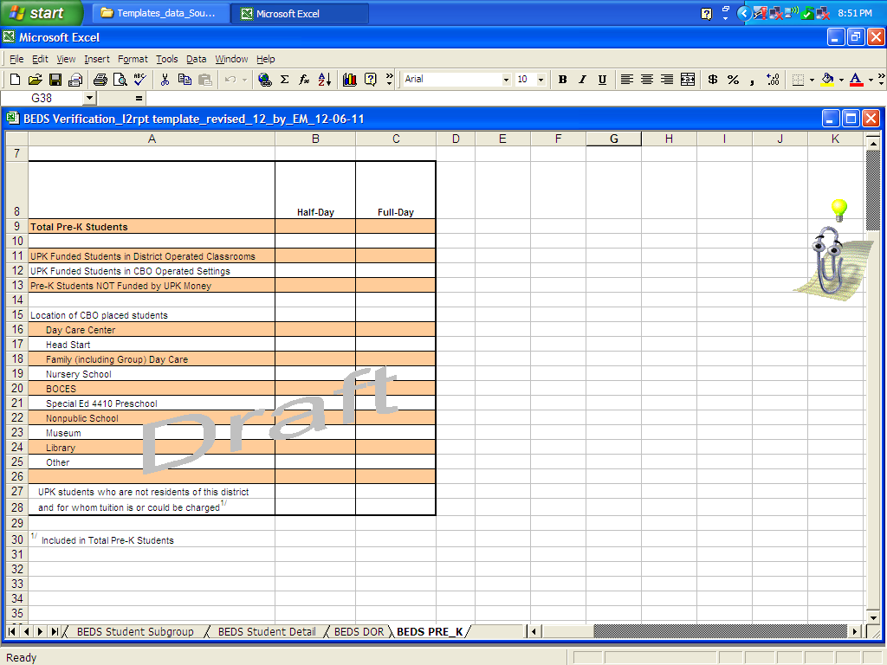

NOTE: The BEDS Online will be the official source of 2011-12 students counts for Pre-K/UPK that will be used in State aid calculations. The 2011-12 Repository records for Pre-K/UPK represent the first year that such detail for Pre-K/UPK has been collected in the student record. Pre-K/UPK detail in the repository for 2011-12 should be viewed as a pilot for this level of detail and an opportunity to sort out procedures necessary to arrive at Pre-K/UPK data in the student records that can be used as the official source for 2012-13. Once a full transition of the Pre-K/UPK data and reliance upon the Repository for these data has taken place, this verification report will replace counts currently collected via the BEDS Online on the District Summary Form in items 1d, 1e and 1f. Those items currently appear on the BEDS District Summary Form as:

- Distribute the total number of students to be reported in the Pre-K section of Item 1a into the following:
 | Universal Pre-K Funded Students  (including former TPK Programs) |  | Number of Pre-K Students NOT Funded by UPK Money
 | Number of UPK Students in District Operated Classrooms | Number of UPK Students in  CBO Operated Settings | Number of Pre-K Students NOT Funded by UPK Money
Half - day
Full - Day

e. Enter the number of Universal Pre-K Students reported in Item 1d who are not residents of this district and for whom tuition is or could be charged …………

- Enter the number of CBO-placed UPK students reported in 1d who are in the following
Community-based Organization settings:
CBO Setting: | Number of  Students | CBO Setting: | Number of Students
Day Care Center |  | Special Ed 4410 Preschool
Head Start |  | Nonpublic School
Family (incl. Group) Day Care |  | Museum
Nursery School |  | Library
BOCES |  | Other

The district total for pre-kindergarten will be a sum of pre-kindergarten students reported as enrolled in any school in the district plus the Universal Pre-kindergarten (UPK) students who are in Community-based Settings (CBOs) and that have been reported with a Location Code ending in “0666”.

The district’s UPK grant coordinator should be consulted by district staff who enter information into the district’s Student Management System (SMS)to ensure that the proper students are reported as UPK using the summary of reporting requirements that follow.

It is important for funding received under a State Universal Pre-K grant that Pre-K students are reported with a proper Program Type, and UPK Setting Type if the Program Type is UPK. A summary of those reporting requirements is as follows:

PreK students that are supported by Universal PreK funds and located in district-operated classrooms should be reported with a PreK Program Type of 902 and a UPK Setting Type of 1309.
PreK students that are supported by Universal PreK funds and located in classrooms operated by Community-based Organizations (CBO) should be reported with a PreK Program Type of 902 and ONE of the UPK Setting Types of 1320 through 1419.

PreK students that are not supported by Universal PreK funds should be reported with a PreK Program Type of 990 and with no UPK Setting Type.

When these Pre-K/UPK reporting rules are translated to the Pre-K/UPK data currently collected in the BEDS Online, they look like:

Universal Pre-K Funded Students  (including former TPK Programs) |  | Number of Pre-K Students NOT Funded by UPK Money
Number of UPK Students in  District Operated Classrooms | Number of UPK Students in  CBO Operated Settings | Number of Pre-K Students NOT Funded by UPK Money
Program_CD = 902  Setting Type CD = 1309 | Program_CD = 902  Setting Type CD = One of 1320, 1331,1342,1353, 1364, 1375, 1386, 1397, 1408,1419 | Program_CD = 990  Setting Type CD = None

CBO Setting: | Program/ Setting | CBO Setting: | Program / Setting
Day Care Center | 902 / 1320 | Special Ed 4410 Preschool | 902 / 1375
Head Start | 902 / 1331 | Nonpublic School | 902 / 1386
Family (incl. Group) Day Care | 902 / 1342 | Museum | 902 / 1397
Nursery School | 902 / 1353 | Library | 902 / 1408
BOCES | 902 / 1364 | Other | 902 / 1419

