L0 – 14.03 Screenshots

Reasonability Manual Import message Screen:
- Revised Reasonability Messaging for Enrollment

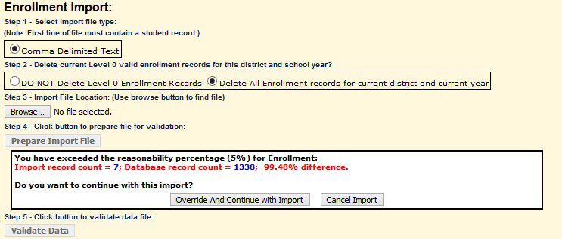

- Add Reasonability Messaging for Staff Student Course
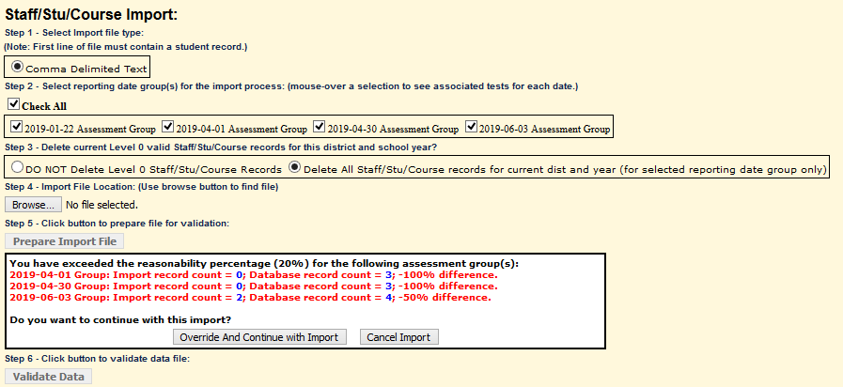

W/F Messages on manual Entry Screen:
- (#301) Include W/F messages on Manual entry screen
  - All applicable Domains with the exception of CIA & Day Calendar

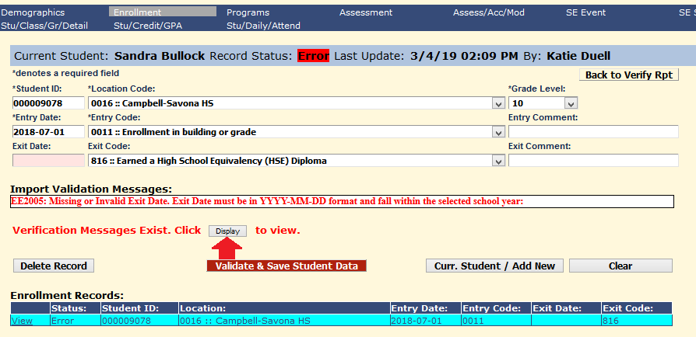

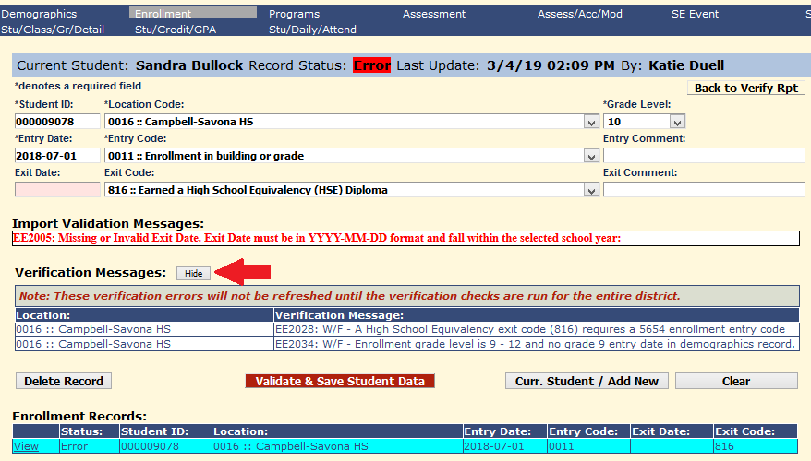

Course Manual Entry Screen:
- (#332) Added wild card search to Course ID or Course Name boxes

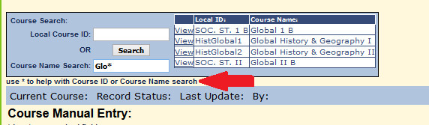

Program Fact Reports:
- (#338) Added Program Intensity column to the drill down report from the Category Breakdown report, for CTE and ELL programs

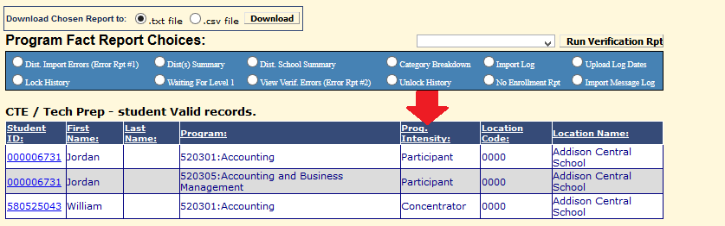

Student Daily Attendance:
- (#325) Added Attendance Summary Breakdown and Detail reports

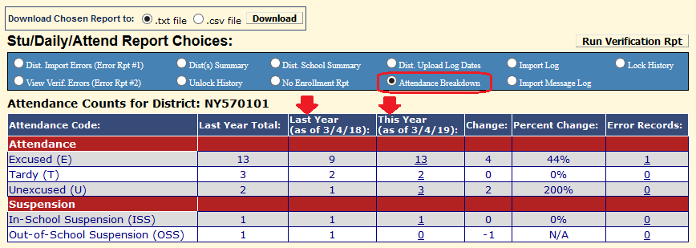

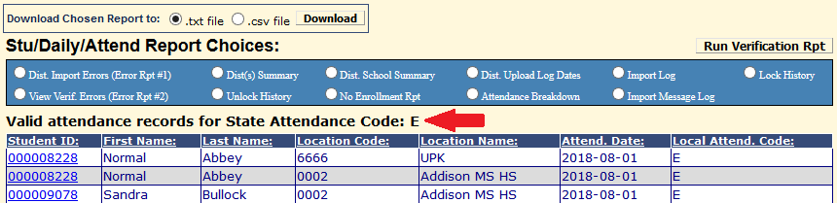

Staff Snapshot Manual Screen:
- (#330) Added TEACH name to display on manual screen after validating against TEACH_ID_LOOKUP table

